4. Find existing issues for all the code snippets presented below. It is highly important to try working this out on paper by tracing through the statements and then input the code into your IDE. Run it to see if you are correct and then see if you can fix the code. You may wish to add additional Console.WriteLine statements to check that variables contain the values you expect. Note that there may be more than one mistake.

A)

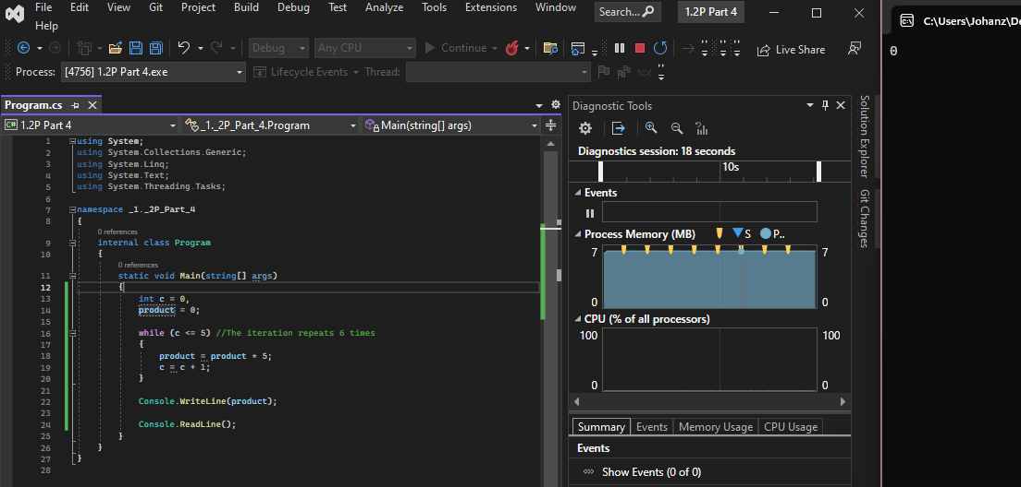

b)

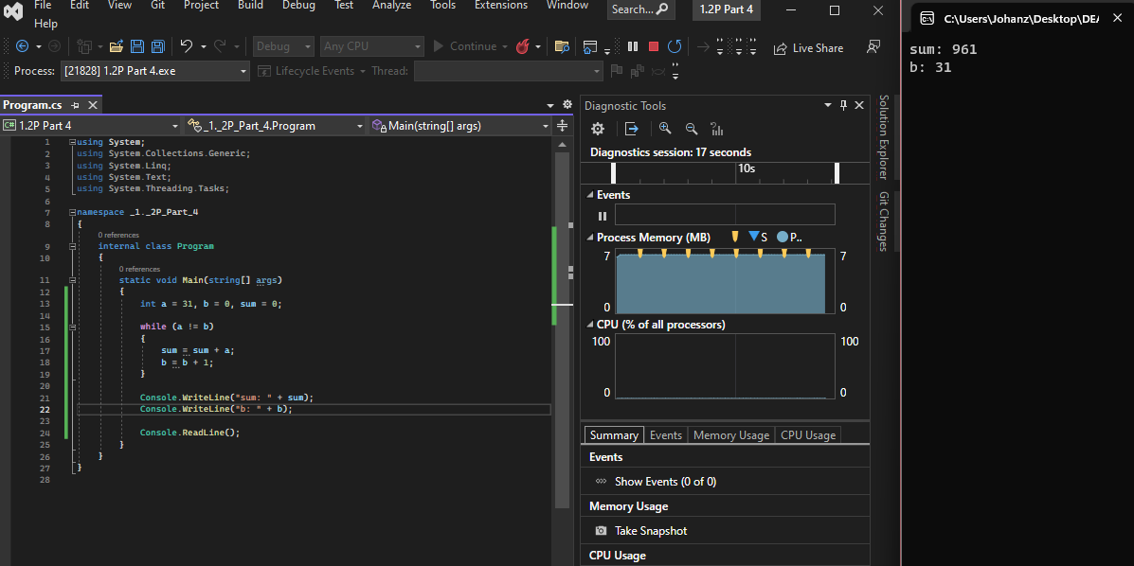

c)

d)

e)

f)

g)

5. Rewrite both of the following fragments of code using for loops instead of while loops.

a)

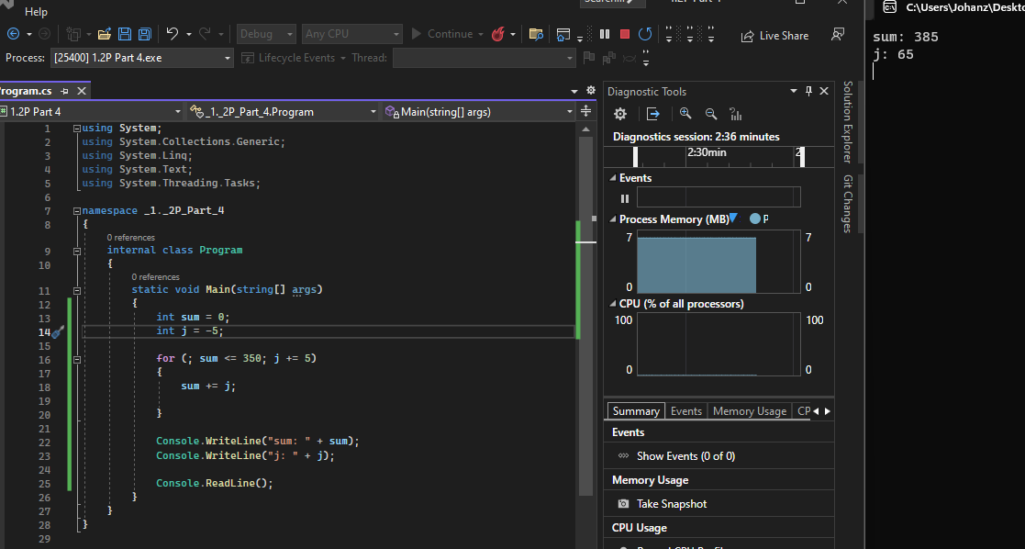

b)

